**STOCK MANAGEMENT SYSTEM**

**A PROJECT REPORT**

SUBMITTED TO

**DR. HITESHWARI SABROL**



|  |  |
| --- | --- |
| **SUBMITTED BY:** | **SUBMITTED TO:** |
| MEGHA KATOCH (12200967)  MANVI (12201077)  MCA (Sem II) | Dr. HITESHWARI SABROL |
|  |  |

**Department of Computer Science & Applications**

**DAV UNIVERSITY, JALANDHAR**

**TABLE OF CONTENTS**

* **ABSTRACT…………**
* **INTRODUCTION……...**
* **LITERATURE VIEW……**
* **PROBLEM STATEMENT….**
* **OBJECTIVE OF PROJECT….**
* **SCOPE OF PROJECT….**
* **ARCHITECTURE SPECIFICATION…**
* **HARDWARE REQUIREMENTS…**
* **SOFTWARE REQUIREMENTS…**
* **SYSTEM DESIGN…**
* **STATECHART DIAGRAM…**
* **ER DIAGRAM**
* **SYSTEM IMPLEMENTATION**
* **OUTPUTS**
* **CONCULSION AND FUTURE DEVELOPMENTS**

ACKNOWLEDGEMENT

I want to convey my heartfelt gratitude to Dr Hiteshwari Sabrol, for her valuable advice and assistance in completing my project. She was there to assist me at every step of the way, and her motivation is what enabled me to accomplish my task effectively. I would also like to thank all of the other supporting personnel who assisted me by supplying the equipment that was essential and vital, without which I would not have been able to perform efficiently on this project.

I would also want to thank the D.A.V University for accepting my project in my desired field of expertise. I’d also like to thank my friends and parents for their support and encouragement during my Minor Project.

This project helps me in

generating knowledge about variety of different things which will prove beneficial to me in future.

**ABSTRACT**

This project is aimed at developing a desktop-based application named Inventory Management System for managing the inventory system of any organization. The Inventory Management System (IMS) refers to the system and processes to manage the stock of organization with the involvement of Technology system. This system can be used to store the details of the inventory, stock maintenance, update the stock based on the sales details, generate sales and inventory report daily or weekly based. This project is categorizing individual aspects for the sales and stock management system. In this system we are solving different problem affecting to direct sales management and purchase management.

Stock Management System is important to ensure quality control in businesses that handle transactions resolving around consumer goods. Without proper stock control, a large retail store may run out of stock on an important item. A good stock management system will alert the wholesaler when it is time to record. Inventory Management System is also on important means of automatically tracking large shipment. An automated Inventory Management System helps to minimize the errors while recording the stock.

INTRODUCTION

The project Inventory Management System is a complete desktop-based application designed on NetBeans Software. The main aim of the project is to develop Inventory Management System software in which all the information regarding the stock of the organization will be presented.

It is an intranet-based desktop application which has admin component to manage the inventory and maintenance of the inventory system. This desktop application is based on the management of stock of an organization. The application contains general organization profile, sales details, Purchase details and the remaining stock that are presented in the organization. There is a provision of updating the inventory also.

This application also provides the remaining balance of the stock as well as the details of the balance of transaction. Each new stock is created and entitled with the named and the entry date of that stock and it can also be updated any time when required as per the transaction or the sales is returned in case. Here the login page is created in order to protect the management of the stock of organization in order to prevent it from the threads and misuse of the inventory.

**LITERATURE REVIEW**

Products are considered as the business resources for the organization. This includes managing the product with appropriate way to review any time as per the requirement. Therefore, it is important to have a computer-based IMS which has the ability to generate reports, maintain the balance of the stock, details about the purchase and sales in the organization.

Before developing this application, we came up with 2 Inventory Management System existing in the market, which helps to give the knowledge for the development of our project. This application software is only used by the large organization but so we came up with the application which can be used by the small company for the management of their stock in the production houses.

After analysing the other inventory management system, we decided to include some of common and key features that should be included in every inventory management system. So, we decided to include those things that help the small organization in a way or other.

**PROBLEM STATEMENT**

After analysing many existing IMS, we have now the obvious vision of the project to be developed. Before we started to build the application team had many challenges. We defined our problem statement as:

¬ To make desktop-based application of IMS for small organization.

¬ To make the system easily managed and can be secured.

¬ To cover all the areas of IMS like purchase details, sales details and stock management.

**OBJECTIVE OF THE PROJECT**

To develop an application that deals with the day-to-day requirement of any production organization

¬ To develop the easy management of the inventory

¬ To handle the inventory details like sales details, purchase details and balance stock details.

¬ To provide competitive advantage to the organization.

¬ To provide details information about the stock balance.

¬ To make the stock manageable and simplify the use of inventory in the organization.

**SCOPE OF THE PROJECT**

Inventory Management System (IMS) is targeted to the small or medium organization which doesn’t have many godwom or warehouses i.e., only to those organization that has single power of authority. Some of the scopes are:

¬ Only one person is responsible in assigning the details or records.

¬ It is security driven.

¬ Godown can be added as per the requirement.

**Architecture Specification**

• The architecture of inventory management system uses client server model.

• The design or architectural specification for the inventory management system is Java since the JSP architecture will be used.

• The Java Database Connectivity (JDBC) will use the MySQL Connector for the server to communicate to the inventory database.

• Upon receiving requests from the clients, the server will issue transactions to the MySQL.

**HARDWARE REQUIREMENTS**

PROCESSOR: 64-bit

ROM: 2GB

RAM: 4GB

**SOFTWARE REQUIREMENTS**

OPERATING SYSTEM: WINDOWS 8/10

FRONT END: JAVA NETBEANS

BACK END: MYSQL

**SYSTEM DESIGNS**

**USECASE DIAGRAM**

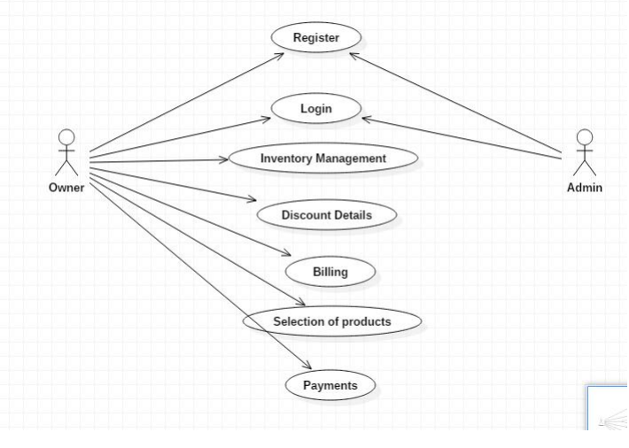

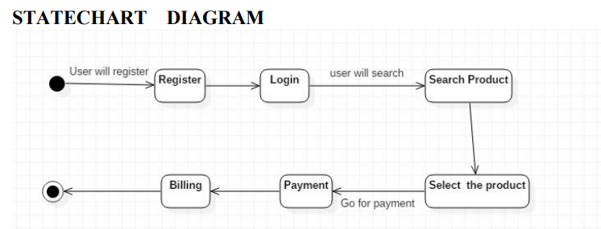

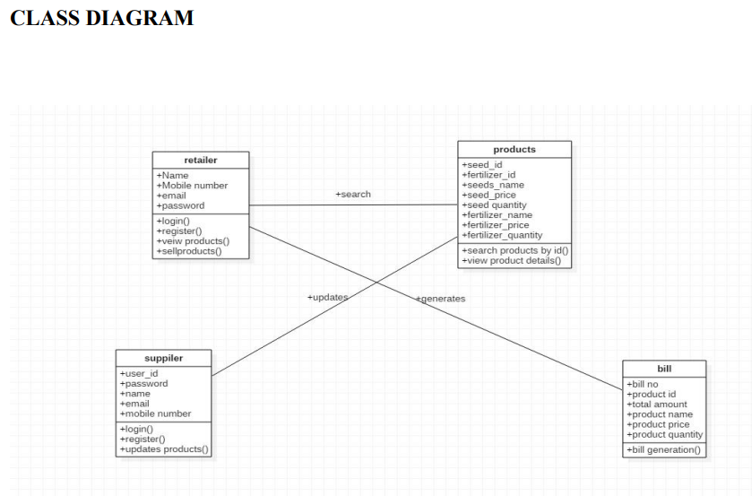

**ER DIAGRAM**

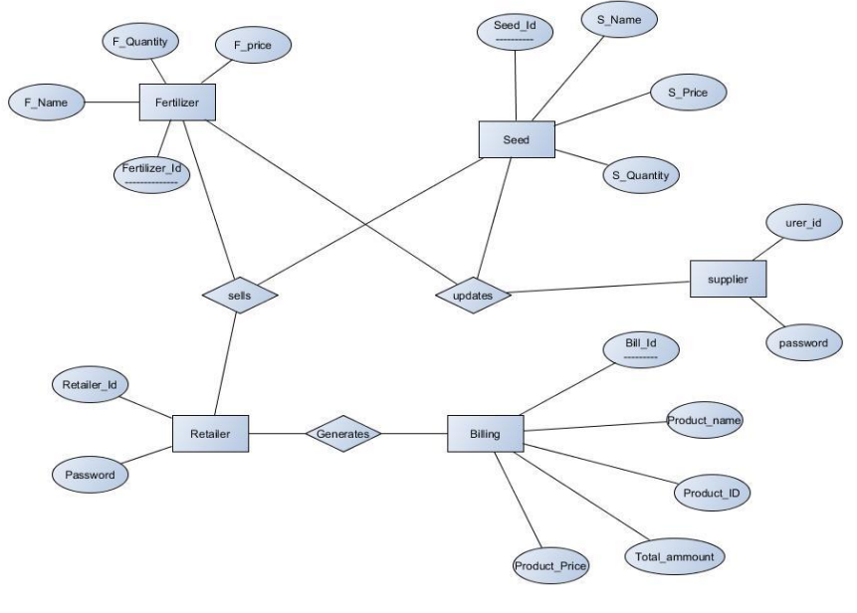

**System Implementation:**

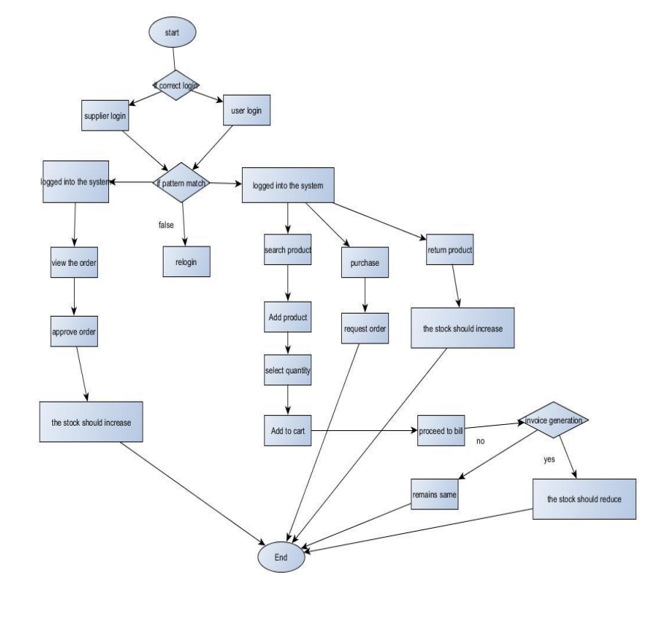

**RESULTS & ANALYSIS**

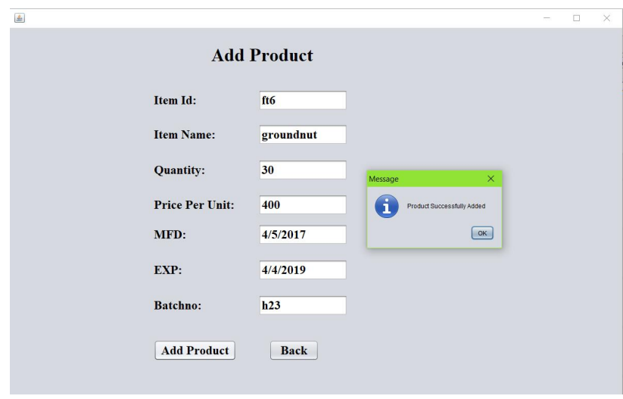

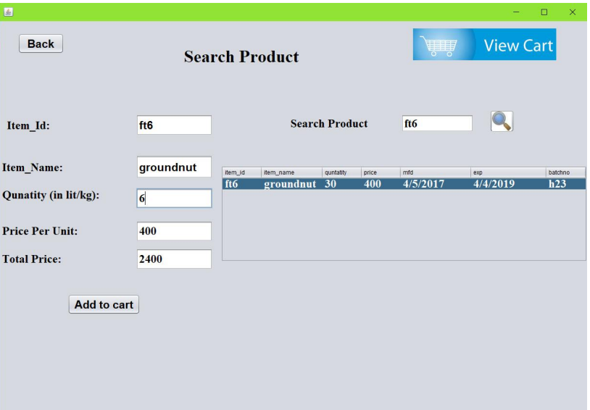

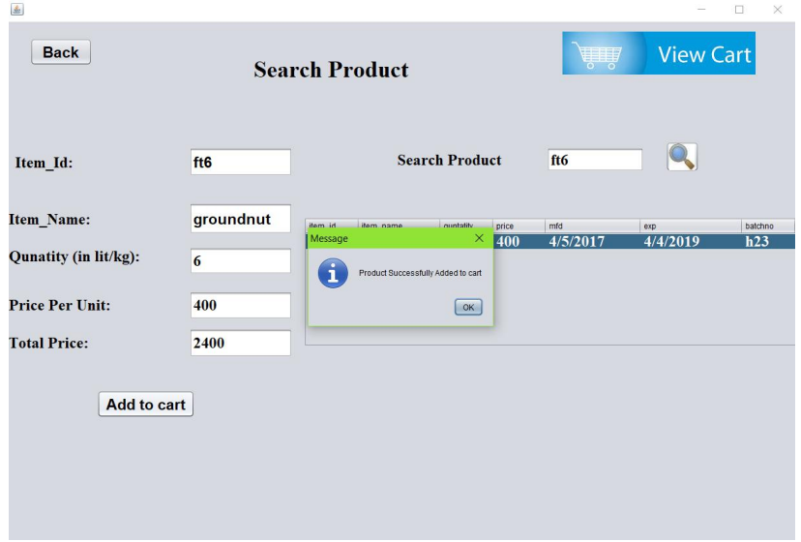

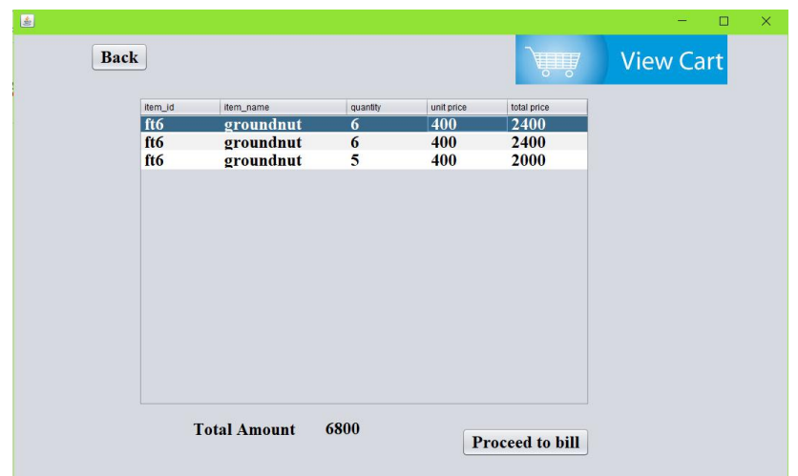

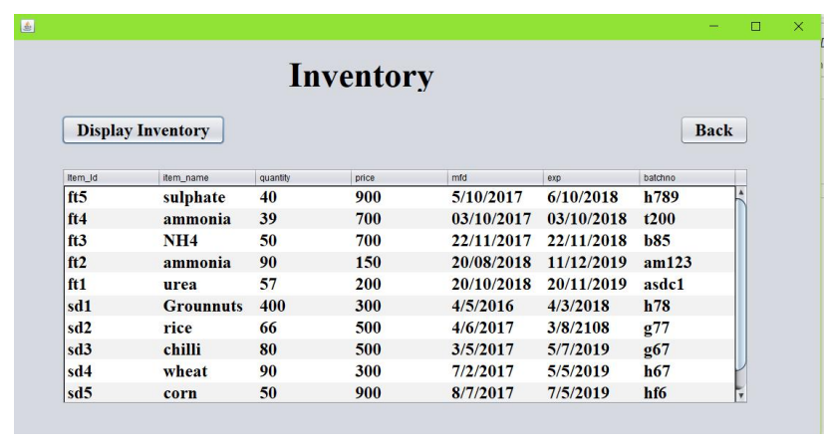

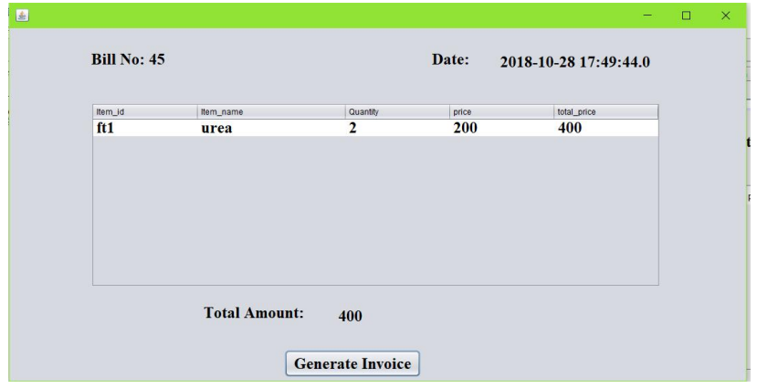

**Conclusion and Future Scope**

In this project we have developed a system which helps the retailers to sell and manage their products easily.

It covers the functional areas such as Marketing and sales, Supply chain management, Accounting and Finance and Human Resources.

So, this can help in increasing the sales of the retailer through the help of the inventory management. So, the required products can be bought based on the demand.

In future the products can be scanned with the help of barcode scanner. A system can be developed to take order from the customers online and deliver them. The customer relationship can be built with the help of feedback.